Tab 1
7. Personal Expense Tracker Develop a Personal Expense Tracker to monitor and analyze spending behavior. Users should be able to log expenses with date, category, and amount. The system should generate monthly summaries, category-wise spending reports, budget breach alerts, and identify high-spending patterns. Analytical insights like highest expense day and dominant spending category must be computed using loops and conditionals

ALGORITHM

1. Start the program.
2. Create an empty list called expenses.
3. Display the menu:
1. Add Expense
2. View Expenses
3. Monthly Summary
4. Category-wise Report
5. Exit
4. Read the user's choice.
5. If the choice is 1:
* Enter the date.
* Enter the category.
* Enter the amount.
* Store the expense in the expenses list
* Display "Expense Added Successfully."
6. If the choice is 2:
* If the list is empty, display "No Expenses Found."
* Otherwise, display all expenses.

7. If the choice is 3:
- Enter the month.
- Calculate the total expenses for that month.
- Display the monthly total.
8. If the choice is 4:
- Calculate the total amount spent in each category.
- Display the category-wise report.
9. If the choice is 5:
- Display "Thank You!"
- Stop the program.
10. Otherwise:
- Display "Invalid Choice."
11. Repeat steps 3 to 10 until the user selects Exit
12.exit.

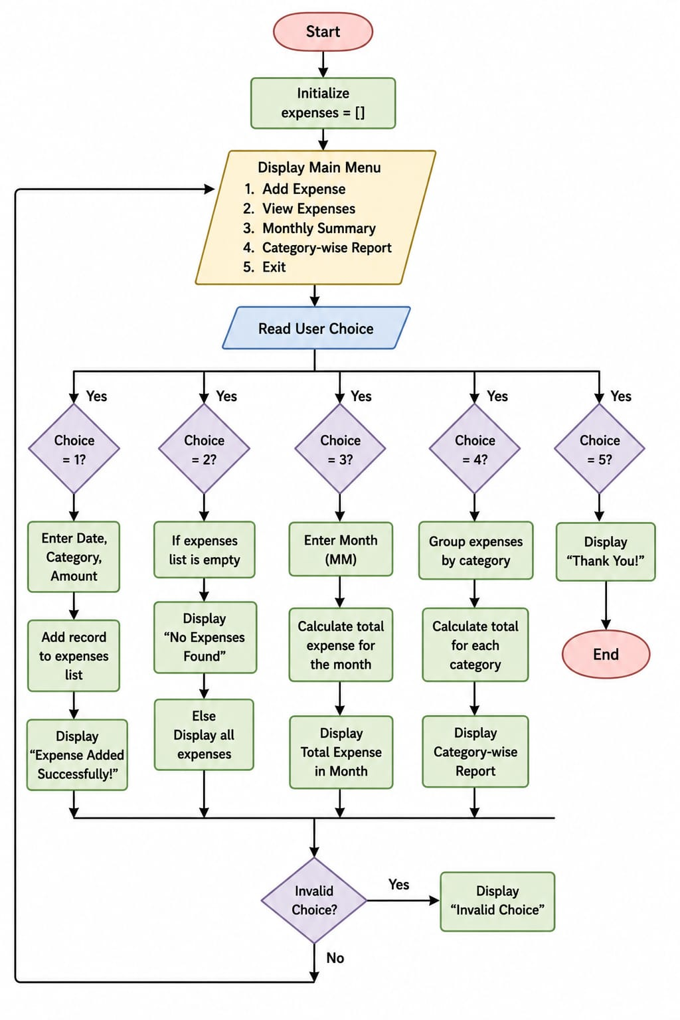

Tab 2

